Please see the item on NHS passport fraud. I received one and it is incredibly convincing.

Cllr. Tina Combellack

From: Rushcliffe Borough Council <rushcliffebc@public.govdelivery.com>
Sent: 29 September 2021 09:22
To: Cllr T Combellack <cllr.TCombellack@rushcliffe.gov.uk>
Subject: Town and Parish Update - Wednesday September 29



Please remember for all the latest on our services visit rushcliffe.gov.uk

Please email media@rushcliffe.gov.uk with any enquiries.

A reminder to everyone to keep testing this Autumn
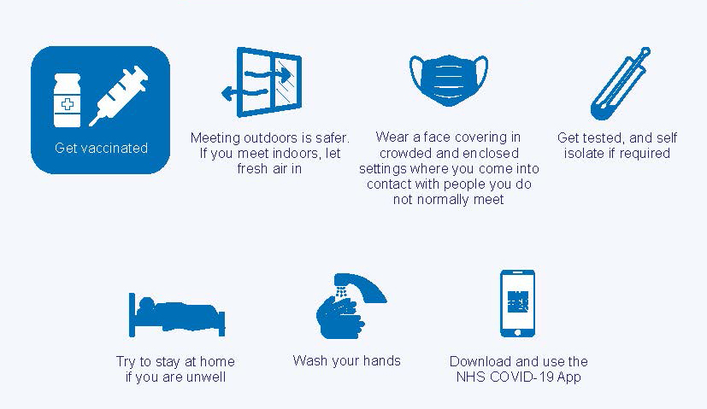
We're continuing to remind everyone to take a COVID-19 regular lateral flow test at home or at one of our Community Testing sites until further notice.
Remember if anyone has symptoms they should book a test.
Meanwhile at Nottingham University Hospitals including QMC and City Hospital, those attending the sites still need wear a face mask, use hand gel and socially distance two metres until further notice to help keep vulnerable patients and staff safe.
A reminder anyone aged 16 or 17 can walk in for their COVID-19 vaccination at selected sites without needing to book an appointment. Locally to Rushcliffe the closest site is Queen’s Medical Centre.
Those eligible can also get a vaccine without an appointment and those who have had their first dose 56 days ago (eight weeks) can walk in for their second dose.
Locally the NHS are now contacting those most at risk for COVID-19 booster vaccines to improve the protection from the first two doses. The NHS will contact individuals at the appropriate time on this.
For all enquiries on Vaccination appointments please visit Nottingham and Nottinghamshire’s CCG website.
For any questions, please email media@rushcliffe.gov.uk.

Celebrating Rushcliffe Awards nominations now open!
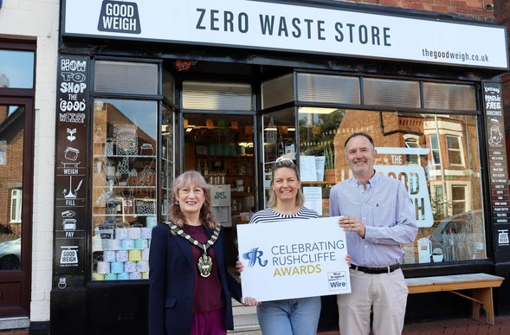
Residents and groups in the Borough are being asked to acknowledge their unsung community, sporting, business and health heroes in our community accolades, the Celebrating Rushcliffe Awards.
In conjunction with media partner West Bridgford Wire, it will celebrate the Borough’s wonderful volunteers, businesses, clubs, organisations, environmentalists, sports teams and athletes and the best of its health and wellbeing and food and drink sectors.
It will also be an opportunity to reflect on those that continue to play pivotal roles in the COVID-19 pandemic and how so many groups and individuals have played incredible parts in assisting Rushcliffe communities and local enterprise in times of need.
Nominations for the 10 awards can be made at https://www.surveymonkey.co.uk/r/CRAs2021 until 11pm on Monday October 18.
Winners will be announced and celebrated in a ceremony later this year.
Our Mayor Cllr Sue Mallender said: “The Celebrating Rushcliffe Awards will highlight some of the outstanding individuals and organisations who truly play their part in ensuring the Borough is a great place to live, has great sport and a great lifestyle.
“It will celebrate a cross section of our communities and the efforts so many people make to be a success in their chosen voluntary efforts, industry or field to contribute to the quality of life in their part of Rushcliffe.
“As in 2020, we will no doubt again celebrate those who have played inspiring roles in supporting their communities in light of COVID-19 as we all continue to help each other.
“Get nominating your heroes now and who you feel deserves acknowledgement for all they have given or achieved.”
The award categories are:
- Volunteer of the Year
- Business of the Year
- Young Person/Group of the Year
- Community Group of the Year
- Sportsperson of the Year
- Sports Team of the Year
- Food and Drink Establishment of the Year
- Health and Well-Being Award
- Environmental Group or Project of the Year
- The Pride of Rushcliffe Award
Kate Cox from The Good Weigh in Lady Bay, last year’s winner of the Environmental Group or Project of the Year joined the Mayor and West Bridgford Wire Editor Pat Gamble to launch this year's awards.
She said: “I would encourage everyone to nominate local people, groups or businesses for a Celebrating Rushcliffe Award.
“Being acknowledged by local people and winning an award was an amazing feeling, moments like it really make all the hard work worth it and want you to achieve even more for a local community.
“It’s been such a tough 18 months for everyone, please take the time to let local people know you value their input and presence where they live.”

Beware of COVID pass fraud
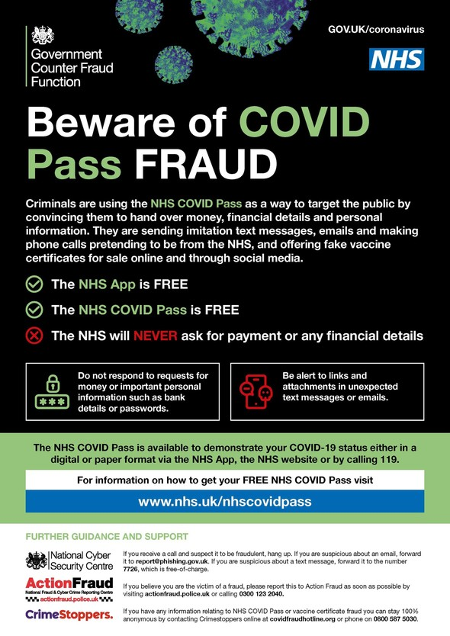
Over recent months there has been a significant increase in scams relating to the COVID Pass to steal money, financial details and personal information from members of the public.
Scammers are sending imitation text messages and emails as well as making fake phone calls posing as members of the NHS to offer fake vaccine certificates for sale online and through social media.
Remember that the NHS App is free. The NHS COVID Pass is free. The NHS will never ask for payment or any financial details.

Town and Parish councils can build sustainable communities

Following Emma Georgiou's presentation at our last Town and Parish forum on Town and Parish councils becoming more carbon neutral, RCAN(Rural Community Action Nottinghamshire) thought they would have a look at what practical measures local councils can take to help build sustainable communities and tackle climate change head on.
Friends of the Earth have conveniently, recently published an article that highlights 20 actions parish and town councils can take on the climate and nature emergency.
This is not an exhaustive list, but it is a great starting point if your council is looking for proactive ways to make positive environmental change happen in your community.
Be a force for Good
1.Encourage the formation of Climate Action groups
2.Support Local Plan policies that help to tackle climate change and boost nature
3.Promote practical action by local people
4.Bring together groups of people for bulk purchases
5.Develop and promote a lift-sharing scheme
6.Use your voice
Demonstrate leadership through your own practical actions
1. Save energy
2. Produce green energy
3. Reduce pesticide use and other harmful activities
4. Manage land for nature.
5. Increase tree cover
6. Buy green
7. Use green transport
8. Minimise waste going to landfill or incineration
9.Ensure money is invested wisely
Use your powers wisely
1. Ensure you know the climate change or nature implications of decisions before you make them
2. Designate sites within the Neighbourhood Plan for trees, renewable energy and nature restoration.
3. Use the Neighbourhood Plan to require new homes to be energy efficient, nature friendly, and located close to public transport and amenities.
4. Designate safe walking and cycle routes in the Neighbourhood Plan
5. Use differential car-parking charges to support low-carbon vehicles
Lists are a great starting point when encouraging discourse. We hope that there is something here that sparks some ideas for change and action.
Fortuitously there are a number of funds and grants available at the moment that are backing climate inspired community projects, both locally and nationally. Strike now while the iron is hot and take the lead on a climate change initiative that is sustainable, and you know your community can get on board with.

Come and play a celebratory round for Edwalton Golf Club's 40th anniversary!
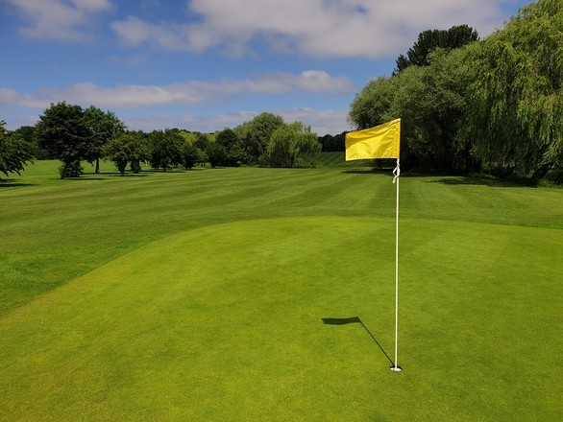
We're helping our partners at Lex Leisure celebrate the 40th anniversary of Edwalton Golf Club next month and asking you to get involved with a fun round of golf!
The course opened in October 1981 when the Lord Lieutenant of Nottinghamshire tee’d off on the 1st at Edwalton to celebrate its opening.
Now you can join an 18 hole competition to celebrate the milestone by taking on the main course 9 hole followed by par 3 nine hole course on Sunday October 17.
Why not set up a team of four to join members of the course in a competitive round or just join friends and do it for fun?
To get involved email our Contracts Performance and Projects Officer Helen Penniston hpenniston@rushcliffe.gov.uk

Afghanistan Resettlement Programme

We are working collaboratively with Government Office and other key partners to assist newly arriving Afghanistan citizens who qualify for assistance under the Afghan Relocations and Assistance Policy.
Nottinghamshire has been one of the first areas to create a countywide offer and in the first instance our commitment is to assist the programme with two property pledges for approximately eight people which has been matched by similar offers from the other Nottinghamshire Districts.
We are working closely with key partners, including Metropolitan Thames Valley Housing and using existing networks via Nottingham City Council and Notts Refuge Forum to provide information and support to ensure successful integration into the community.
For those wishing to offer accommodation, follow the information on the government’s web pages.
Anyone can make donations such as clothing toys etc via Care4Calais, The Refuge Council and the British Red Cross who are appealing for donations and supporting many newly arrived families from Afghanistan. More locally, Host Nottingham are accepting donations for asylum seekers or refugees which may include assistance for Afghanistan citizens.
The list of donations being sought is:
Women's items:
- Tops
- Leggings
- Hoodies / warm tops
- Sportswear
(All sizes 6-18 nothing larger)
Men's Items:
- T shirts
- Jeans
- Joggers
- Jackets
- Trainers (sizes 8,9,10 and half sizes)
- Sportswear
(Medium and Large)
Underwear and socks for men and women (brand new in packets)
(Men’s pants Medium and Large - Women’s size 10 – 16)
Toiletries for men and women (unopened)
Shower gels, deodorants and body sprays
Extra items
Phones - unlocked, wiped and working and rucksacks and wheeled suitcases.
For more information and to arrange delivery, please email hostaccompanying@gmail.com or call 07735 551 362 or 07986 012 013.

East Midlands Freeport reaches important milestone

Plans for the UK’s only inland freeport have taken a major step forward after an outline business case was submitted to the Government.
The East Midlands Freeport would take in three key sites: East Midlands Airport and the industrial sites around it, the Ratcliffe on Soar power station site here in Rushcliffe, which is a due to be redeveloped after closing in 2025 and the 5.2 million sq ft East Midlands Intermodal Park near the Toyota plant in Derbyshire.
The document is part of the process that Government has designed to make all of the planned freeports in England operational as soon as possible and builds on the success of the initial East Midlands Freeport bid earlier this year.
The technical information contained in the document includes analysis that demonstrates how the freeport will contribute around £8.4 billion to the East Midlands economy over the next 30 years alongside its potential to support and create around 55,000 jobs.
The blueprint centres on the East Midlands Freeport’s unique strengths as the UK’s best-connected freeport, located at the heart of the nation’s advanced manufacturing and logistics economy, with plans to boost skills and accelerate the region’s commitment to cutting carbon emissions.
The next stage of the development process will see further plans submitted in December with the ambition to make the freeport fully open for business by March next year.
A wide range partners are behind the bid which is founded on strong public and private sector collaboration.
Freeports are designed to attract major domestic and international investment - they allow places to carry out business inside a country’s land border but different customs rules apply.
At a freeport, imports can enter with simplified customs documentation and without paying tariffs. Businesses operating inside designated areas in and around the port can manufacture goods using the imports and add value before exporting again, without ever facing the full tariffs or procedures.
If the goods move out of the freeport into another part of the country, however, they have to go through the full import process, including paying any tariffs.
More information can be found on the Freeport's new website www.emfreeport.com

Rushcliffe Country Park users asked how and when they visit
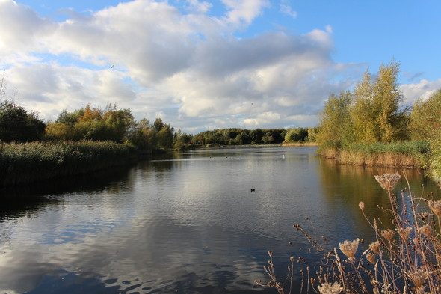
Those of us that enjoy a visit to Rushcliffe Country Park are being asked to give their views in a bitesize survey, designed to help shape the park’s features and gauge further how they travel to and when they use the site.
The short survey, which can be completed at https://bit.ly/3t20tVF until tomorrow, September 30, will help identify more how visitors use the park.
It will also assist our continued application for annual Green Flag accreditation for the site that regularly requests views and feedback from park users.
Responses could also help develop subsequent new visitor attractions, features and car parking to inform a wider consultation next year.
Whether visitors use the park more than once a week or just once a year, all views are being sought to help shape wider assessments and ongoing improvements in future years.
The park’s education centre and separate toilet block and tool store will also soon undergo a wider refurbishment to make use of its green spaces including installation of solar panels to generate over 80% of the energy requirements of the site.
This is due to start later this year and will include enhanced toilet facilities and a takeaway café.

Car parks return to normal charges from September 30
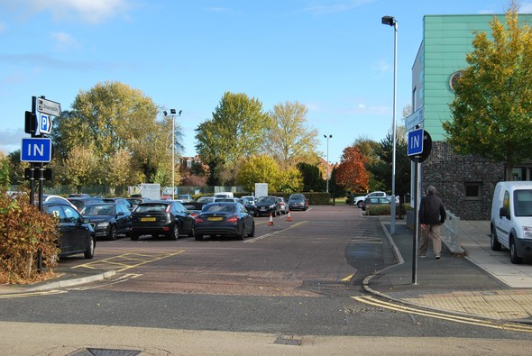
Our free parking promotion across our car parks, Free After 3, is set to expire tomorrow, September 30.
We have supported retail and hospitality in locations across the Borough when it brought in the initiative in April to support local business as they were recovering from the COVID-19 pandemic.
With many businesses now trading full time again on high streets in West Bridgford, Bingham, Radcliffe on Trent and Keyworth and locally larger sporting events again taking place, we are returning to pre-COVID parking operations at our sites.
This is to assist further turnover of spaces at the popular facilities in line with our Off Street Car Parking Strategy.
We will continue to review our car parking policy and charges in line with any central Government changes as a result of the pandemic and has decided to make the change to assist with providing a continued sustainable service.
Charges at car parks are re-invested back into facilities that ensure they are safe and attractive with maintenance on lighting, resurfacing, ticket machines and improvements such as the highly popular RingGo service and electric vehicle charging points.

Charities and groups encouraged to apply for Police and Crime Commissioner’s Make Notts Safe Fund
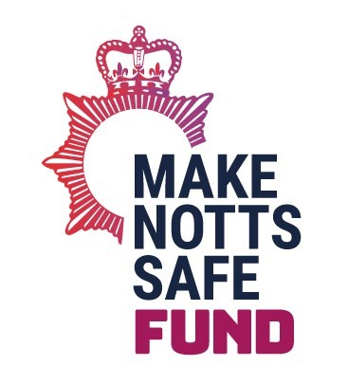
Nottinghamshire Police and Crime Commissioner Caroline Henry has launched her landmark Make Notts Safe Fund to provide funding directly to charities and organisations working within communities to make Nottinghamshire safer.
From an initial funding pot of £100,000, not for profit organisations and charities across the county can bid for up to £10,000 to fund projects focused on preventing crime, responding to issues of greatest concern in communities, and delivering victim and community support services.
The Commissioner said: “Earlier this year, I committed to making more money available for areas across Nottinghamshire. This is why I am proud to be launching our new Makes Notts Safe Fund. I am determined that every penny we spend starts to be seen in towns across our county – this fund will ensure that.”
“This fund puts the power back in the hands of organisations on the ground to help us deliver real change by funding projects that have a tangible impact on making residents feel safer. I would encourage all organisations across the county to apply so we can work together to Make Notts Safe.”
Successful applications from organisations across the county will help deliver on the Commissioner’s priorities, which include preventing crime, responding to community needs, and supporting victims, survivors, and communities to be safe and feel safe.
This launch is part of the Commissioner’s wider plans to assist the work carried out by organisations within communities to improve safety across the county. She is planning on making available a further Make Notts Safe funding round in 2022/23, subject to future funding confirmation.
Applications are now open for organisations to apply via the Commissioner’s website.

Thousands enjoy Proms in the Park!
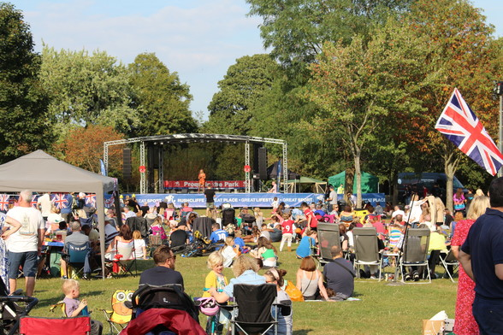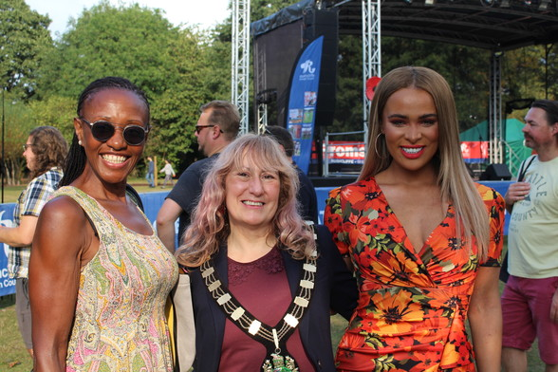
Our Proms in the Park event celebrating Armed Forces Day took place on September 18 and the wonderful event was enjoyed by thousands of residents and visitors in glorious sunshine!
It was postponed in June due to COVID-19 restrictions and hence this year was a belated celebration but it was still a great opportunity to show appreciation and support to those who sacrifice their time and their lives in service of the British public.
The music programme was introduced by our Mayor Cllr Sue Mallender who also welcomed local Armed Forces representatives. The performers included youth steel band Pure Streel, Nottingham's own operatic soprano Faith Tucker, the ZCC Brass Band and concluded with a headline performance from the New West End Jersey Boys.
The local Royal British Legion in attendance also thanked event goers as they raised over £500 for the Poppy Appeal on the day.

Help to Grow funding available from Central Government

The government’s new Help to Grow: Management programme can help business owners learn new skills, reach more customers and boost their profits.
The programme costs £750 and is 90% subsidised by the government as part of their Plan for Jobs.
It is a practical management training programme with one-to-one mentorship, aimed at senior leaders of small and medium businesses and delivered across the UK by leading business schools accredited by the Small Business Charter.
Designed to be manageable alongside full-time work, the 12-week programme offers a wide range of modules, including financial management, strategies for growth and innovation, leading high-performance teams, and approaches to digital adoption.
Business owners can learn more by visiting https://helptogrow.campaign.gov.uk/.

Is your Town or Parish Council looking for support to develop your community?
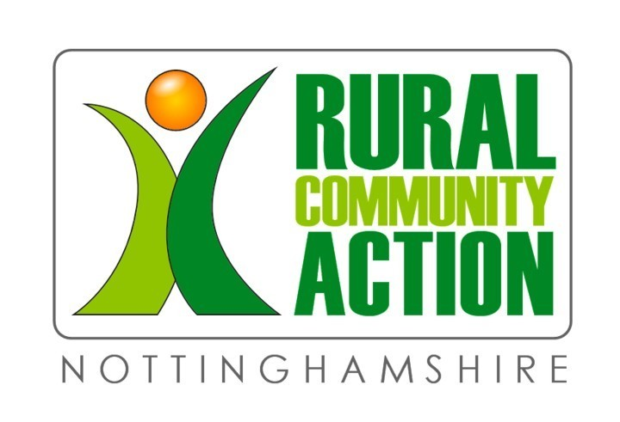
Since 1924 Rural Community Action has supported communities across rural Nottinghamshire. They provide expertise and advice on:
Community planning | Transport and Access Support | Consultation and engaging the community | Health and Wellbeing | Economic Regeneration and funding |Regional Rural Policy
RCAN is committed to Raising the Rural Voice!
If you think you would benefit from RCAN’s membership scheme. Get in touch. Annual membership is just £95 + VAT.
For more information and an application form email enquiries@rcan.org.uk or call 0115 6975800 or visit their website.

All the latest information for residents is available on the Coronavirus webpages or over the phone on 0115 981 99 11.

Manage Subscriptions | Unsubscribe All | Help
Stay Connected with Rushcliffe Borough Council:


This email was sent to cllr.tcombellack@rushcliffe.gov.uk using GovDelivery Communications Cloud, on behalf of: Rushcliffe Borough Council · Rushcliffe Borough Council, Rushcliffe Arena, Rugby Road, West Bridgford, NOTTINGHAM, NG2 7YG | 

This message and any attachments are for the named person's use only. It may contain information that is commercially sensitive, of a confidential nature or contain protectively marked material up to OFFICIAL (SENSITIVE) and should be handled accordingly. No confidentiality or privilege is waived or lost by any mistransmission. If you receive this message in error, please immediately delete it and all copies of it from your system, destroy any hard copies of it and notify the sender. You must not, directly or indirectly, use, disclose, distribute, print, or copy any part of this message if you are not the intended recipient. Whilst every endeavour is made to ensure that any attached files are virus free, we would advise that a check be performed before opening. Rushcliffe Borough Council and any of its subsidiaries each reserve the right to monitor all e-mail communications through its networks. Any views expressed in this message are those of the individual sender, except where the message states otherwise and the sender is authorized to state them to be the views of any such entity. Rushcliffe Borough Council accepts no liability for any personal views expressed. Senders and Recipients of email should be aware that, under the General Data Protection Regulation and the Freedom of Information Act 2000, the contents of the message and any attachments may have to be disclosed in response to a request made under either piece of legislation. Any personal information that that you provide in response to this email, or in any other communication with

