SUMMER NEWS LETTER



Rushlcliffe Borough Councillor - Tina Combellack’s
News for the Nevile & Langar Ward
Colston Basset, Langar, Kinoulton, Hickling, Upper Broughton, Owthorpe and Hickling Pastures

THANK YOU

What an amazing response there has been throughout this Ward and across the Borough to the Covid crisis. The community was mobilised in an instant. We have to thank everyone who has been involved, shopping, delivering, communicating, sewing, painting, baking, cooking and much more – doing all the things for people that make us human.

Rushcliffe would like to thank each and every one of you if possible. So I need a list of everyone involved. I appreciate this might not include all, as some people will wish to remain anonymous but a big thank you anyway.

IT AND THE DIGITAL WORLD

It’s been remarkable how quickly we have adapted to using digital technology. We have all resisted the change from paper to web filing - money to plastic - face-to-face meetings to Zoom, Teams, and Skype. So what seemed a slow transition to a new world has happened in a flash.

NATURE & THE ENVIRONMENT

Hasn’t it been quiet – you could hear the birds; the world seemed alive even though we were in lock down. The air was clearer and colours brighter - all things we should treasure. Rushcliffe are already been looking at the outcomes from the Covid crisis – what lessons we have learnt, what we could have done better, how we would cope if it happened again.

RUSHCLIFE getting CARBON CLEVER
reducing it’s footprint by 2030

In March the Council’s Cabinet approved plans to become ‘Carbon Clever’ and reach the 2030 deadline with an added £1m towards the reserve in conjunction with innovations from an internal working group that is now implementing changes.
Rushcliffe Borough Council is taking further steps towards its goal for its operations to be carbon neutral by 2030 with the creation of a Team Manager for Environment in its Community Development team. Despite the pressures of COVID-19 on the authority, it is continuing with its green priorities to recruit to the role and demonstrate its commitment towards recovering from the pandemic in line with its further investment in its Climate Change Action Reserve. The Carbon Management Action Plan is to tackle Property Assets, Fleet, Policy and Regulation in the organisation to reduce emissions over the next decade.

PLASTIC WASTE – unfortunately we seem to have forgotten all about not using single use plastics. The current crisis has meant a lot more plastic waste the following tips from Veolia might just reawaken the ‘anti plastic fairy’

How can you cut down your waste this summer?

Reduce
- Many shops offer fruit and vegetables without any packaging, so if you can, choose the no packaging options, or take along your own containers to be filled.
- Instead of wrapping everything in tin foil or cling film before it goes in your picnic hamper, why not reuse a container, or have a look a some of the super reusable waste free ways to store food like beeswax wraps.

Reuse
- Reuse empty bottles and jars, old jars of pesto can be used to keep homemade salad dressings or to store snacks for your lunch at work.
- Fill and take your own drinks bottle or thermos with you on your adventure, lots of places in Nottinghamshire now offer refills for water bottles too. Remember the ’REFILL RUSHCLIFFE’ campaign.

Recycle
- If you don't see any recycling bins while you're out and about, please make sure you bring home your plastic bottles and cans so they don't go to waste.
- Apple cores, banana skins, strawberry tops and orange peels can all go into your home composting bin to recycle them into compost.
II am still collecting plastic bottle tops, which, when sold for recycling, provide money for Dove Cottage Hospice. So drop them off to me when you have saved up a bag full.

If you have to have single use plastic punnets recycle them in the garden. They make wonderful seeds boxes and propagators.

Plastic lemonade bottles are good as bird scarers, cane toppers and earwig catchers among the Dahlias. Just be inventive.

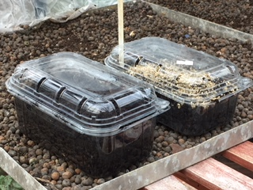

Second phase of discretionary COVID-19 grants now available for eligible business owners

Rushcliffe Borough Council is now inviting applications from eligible business owners on a second phase of COVID-19 Discretionary Business Grants Scheme designed for those yet to receive central government financial support.

This grant is aimed at small businesses who were not eligible for the Small Business Grant Fund or the Retail, Leisure and Hospitality Fund payments in April and who may have been unsuccessful with applications to the first phase of discretionary support outlined in June.

This central government support has now been reviewed with newly revised terms. Previous applicants do not need to reapply. The Council will contacting them should they now be eligible for the funding.

VILLAGE EVENTS & Activities

Sadly, for safety reasons, Hickling have had to cancel their Scarecrow weekend and Kinoulton their village show. However I am sure all villages are working on safe community activities. I know there are Zoom quizzes, bingo nights, open gardens and much more. The pubs are now open for socially distanced drinking. I attended the pulling of the first pint by the Local MP Ruth Edwards at the Nevile Arms in Kinoulton on July 4th

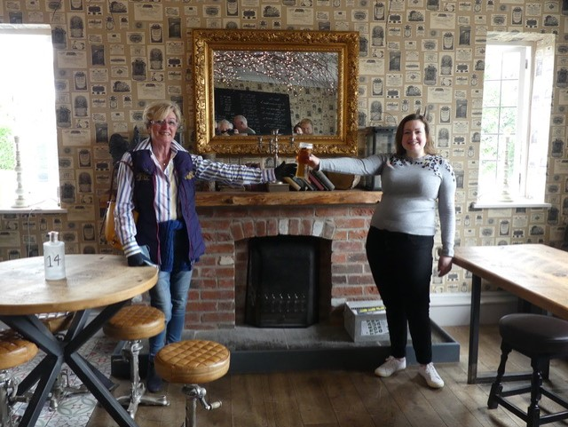

Stay safe, stay well, be alert and have a wonderful summer

Cllr. Tina Combellack
Cllr.tcombellack@rushcliffe.gov.uk

