- 23rd April 2022, 7:30pm  Charity Show for The children of Ukraine  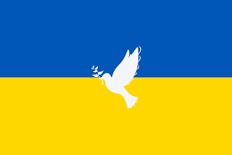  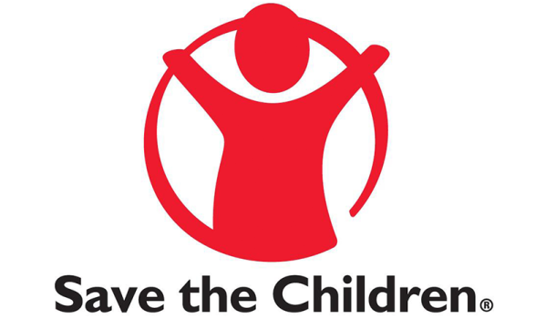  Colston Bassett Events, in partnership with Save the Children, present a charity concert for the Children of Ukraine, featuring the fantastic Opera Dudes – a unique act with huge stage presence.
  Tickets £20, to include light refreshments
  BOOK NOW:
  John Jennings
  07860 507844
  Email:
  cbvvevents@
  hotmail.com
  Doors open 7pm Bar available
  Tickets in advance
  All proceeds to the Ukrainian Save the Children Emergency Fund
  ____
  Can’t make it? Donate:- https://www.justgiving.com/fundraising/john-jennings11
  ____

