

Monday, January 4

COVID-19 vaccine – please wait to be contacted and then respond promptly

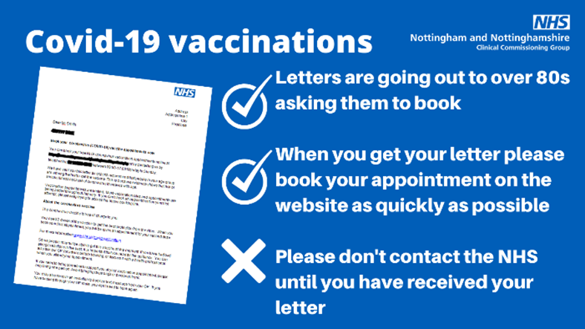
Across Nottingham and Nottinghamshire people over the age of 80 are being contacted to book their Covid-19 vaccination.
In the next few weeks, over 80s will receive a letter from the NHS explaining how to book their appointment.
Health bosses have asked the public to wait until they have received their letter before contacting the NHS, their GP or local hospital hub – the letter will have full details of how to make an appointment.
No one should call their GP or turn up at A&E or a doctor’s surgery – the only way to get an appointment and the jab is to follow the instructions in the letter.
Amanda Sullivan, Accountable Officer at Nottingham and Nottinghamshire Clinical Commissioning Group, said: “This is the biggest vaccination programme the NHS has ever undertaken. It is a huge challenge and one that has been rolled out at great pace.
“Our teams are working really hard but it’s important to remember this is only the first stage of the programme so we are learning and improving as we go.
“We understand many people are keen to see their family get the vaccine as soon as possible to protect them from getting seriously ill.
“Details of how people over the age of 80 make their vaccine appointment have been shared and used amongst other, less vulnerable groups.
“If you see a message directed at an 80 year old or someone who is most at risk asking them to book to receive a vaccine, please don’t log on or pick up the phone unless you are calling on their behalf. We need to protect the appointments for those most in need.
“In time, everyone will be vaccinated so for now we are urging the public to work with us and be patient so we can first vaccinate those who need it most.”
The roll out of Covid-19 vaccines to people most in need began at the two hospital hubs, Queens Medical Centre and Kings Mill Hospital, in early December.
Teams across the health and care system in Nottinghamshire are now preparing for a further roll out of the vaccine into the community for those over 80 years old. During January Local Vaccination Services at GP surgeries and other community sites will start to open across Nottinghamshire.
The public have an important part to play to help:
• please don’t contact the NHS to seek a vaccine, we will contact you;
• when we do contact you, please attend your booked appointments;
• and please continue to follow all the guidance to control the virus and save lives.
Visit the NHS vaccination pages for Nottinghamshire to find the latest information.
Please observe restrictions as Rushcliffe remains in Tier 4
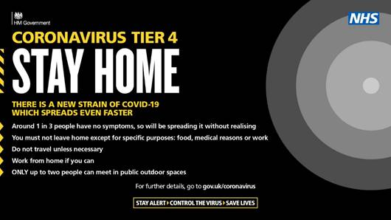
Residents are being urged to adhere to the latest Tier 4 restrictions that remain in place across the county.
This means Nottinghamshire residents cannot leave or be outside of the place they are living unless they have a reasonable excuse. The Government has provided guidance on when it is reasonable to leave the place where you are living.
You also cannot meet other people indoors unless you live with them, or they are part of your support bubble.
Outdoors, you can only meet one person from another household.
Another example of when you can leave home is to buy things at shops or obtain services from a business which is permitted to open.
Parents can still take their children to school, and people can continue existing arrangements for contact between parents and children where they live apart. This includes childcare bubbles.
All the restrictions can be found on the Government website: Tier 4: Stay at Home - GOV.UK (www.gov.uk)

Customers reminded not to linger outside food and drink takeaway outlets

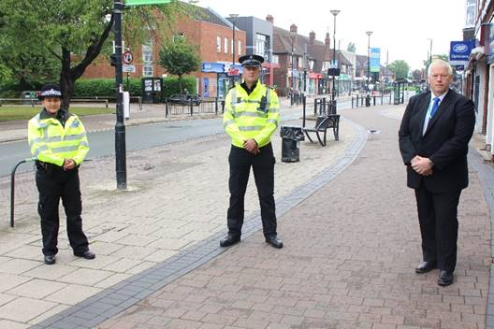
Residents in the Borough are being reminded to not linger outside food and drink takeaway services to help play their part in stopping the spread of COVID-19.
As high numbers of positive cases continue to make national headlines, over 100 people were witnessed congregating outside bars on Central Avenue in West Bridgford on Christmas Eve.
They had in many cases purchased food and drink from local outlets but were not following the rules to consume the items away from the businesses and were not sufficiently socially distanced.
Officers from Nottinghamshire Police dispersed the groups, understanding those wishing to support local businesses but highlighted local COVID-19 restrictions should be followed at all times.
We have now worked with and reiterated to the business owners in the area on how to implement the restrictions to customers, as Tier 4 restrictions mean hospitality businesses are able to continue a takeaway offering.
We’re also reminding all that a local Public Spaces Protection Order (PSPO) is in operation in West Bridgford for everyone’s benefit.
It means park users and town centre visitors must give up alcohol when asked to do so by an official and failure to comply can lead to a fixed penalty notice or prosecution at court and a fine of up to £1,000.
High Street Ambassadors are also continuing to provide advice and reassurance at sites across the Borough, highlighting signage that reiterates the measures to follow at each location.
Our Cabinet Portfolio Holder for Neighbourhoods Councillor Rob Inglis said: “We are monitoring this breach of Tier 4 restrictions in partnership with Notts Police very closely.
“Patrols sadly witnessed that some outlets in West Bridgford continue to allow groups to form outside following the purchase of takeaway items. This is not acceptable, nor will it be tolerated. Individuals must also take personal responsibility.
“We recently appealed to all customers to not linger outside food and drink takeaway outlets to play their part in stopping the spread of COVID-19, to remember ‘Hands Face Space’ and consume items away from the premises and in line with the rule of one outdoors in Tier 4.
“We continue to work with business owners on how to implement the restrictions to customers and their responsibilities in line with the local Public Spaces Protection Order.
“It means town centre visitors must give up alcohol when asked to do so by an official and failure to comply is now likely to lead to a fixed penalty notice or prosecution at court and a fine of up to £1,000.”
Gotham-Clifton road to close for six weeks with diversions in place

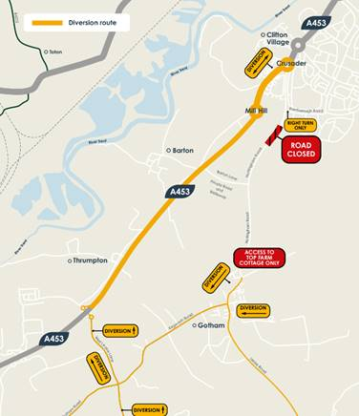
Nottingham Road between Gotham and Clifton will be closed for six weeks in January and February to allow for a new junction to be built as part of enabling works for the £800 million Fairham development.

The closure will take place from Monday January 18 to Sunday February 28 to enable the safe construction of a new staggered road junction to create access to the new development either side of the existing road and forms part of the longer term ambitions for traffic calming in the area.

There will be diversions in place for Nottingham Road from Gotham in the south and Clifton in the north for all vehicles, cyclists and pedestrians, with signed diversions for cars, a designated cycle route and pedestrian access via the existing public right of way track through the fields to walk between Clifton and Gotham.

All motorised traffic will be re-routed via the A453 at the Gotham/Thrumpton junction coming from the south, east and west, and via the A453 at Crusader Island coming from the north.

Nottingham City Transport Bus Service 1 will be diverted during these works. All diversion plans are available to view and download at www.fairhamlife.co.uk

Rushcliffe landlords invited to free webinar this month

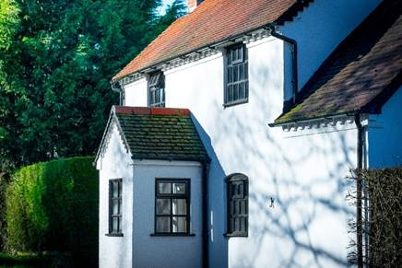
Landlords in Rushcliffe are being invited to join a free webinar next week, featuring local and national updates, in lieu of the usual in-person forum offered by South Nottinghamshire Councils.

We’re hosting the new online event at 10.30am on Wednesday, January 13 in partnership with Gedling Council, Broxtowe Council and DASH Services.

The National Residential Landlord Association will also be present to give an update.

Attendees can register their interest and find out more by visiting the Eventbrite page.

East Leake Parish Clerk celebrates 25 years with the Council

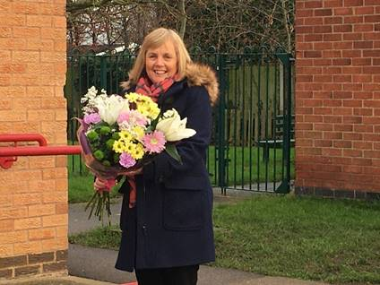
East Leake Parish Council recently surprised Sue Lewis with a brilliant bunch of flowers to celebrate 25 years of service.

Sue first started working with the Council on January 4, 1996 and has been helping the local team ever since.

Members of the Council are looking forward to working with Sue for many more years, following her recent appointment as the new Parish Clerk.

Have your say on our Planning Enforcement Policy


We are reviewing and amending our Planning Enforcement Policy. It allows us to intervene should a breach of planning control take place and assess any harm that is caused.

Have your say on how we apply this here before January 29: https://bit.ly/3myHv41

Keep sharing photos of your local communities

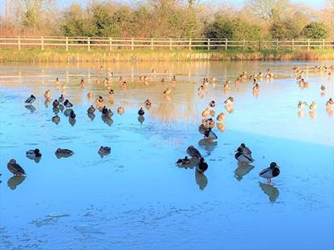
Thanks to our Deputy Mayor, Cllr Tina Combellack for sharing this great photo of some chilly ducks in her ward of Hickling during the Christmas break.

If you have any photos of your ward, whether they’re brilliant landscape shots, snaps of local wildlife or pictures of great community efforts, please share them with us at media@rushcliffe.gov.uk

Virtual Communications Training Opportunity


With many meetings and conversations now taking place virtually, have you ever wondered about the effectiveness of your online presence?

Are you presenting the right image, are you communicating effectively, are you getting your point across in a meaningful way, could you be making more of an impact?

To help you make the most of your virtual communications, we have invited Keith Daniell from The Media Group to run an online Virtual Communications training session on Monday, January 25 at 6pm.

The session is practical, interactive and fun. You will walk away with some very simple pointers that will improve the effectiveness of your virtual communications.

Hopefully Covid-19 isn’t here to stay but technologies such as Zoom, MS Teams and Skype may well be.

Learn how to make the most of a ‘fish’, a ‘Michelle’ and your smile by joining Keith and getting 2021 off to a cracking start.

Please email Democraticservices@rushcliffe.gov.uk to book on to this session.

COVID digital recovery grant to give businesses a further boost

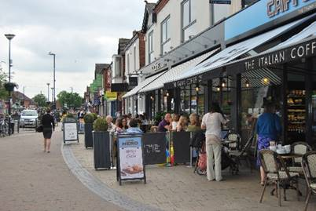
We are giving eligible high street businesses or established business groups another boost with a COVID Digital Recovery Grant that can further help them adapt and improve their online presence or sales.

Small to medium size retail, hospitality, personal care, leisure, tourism and other enterprises in the Borough can now access up to £1,000 over and above existing central government grant support by visiting https://bit.ly/3lQWfuG

Part of our recovery plan on the pandemic, the funds allow businesses to create or improve a website, seek advice and support on improving their social media presence or create greater online transactional capability.

It can also aid local retail groups or traders’ associations supporting or enhancing the development of, for example, an online market place for their town or village.

Applicants must be a High Street business who pay their business rates to the Council or receive small business rate relief with between 1.5 and 30 employees.

All appropriate licences and permissions must be in place and full criteria is available on the webpage.

Census 2021 roles available


Next year will see the Census 2021 take place and there's set to be lots of temporary job roles available for residents at http://orlo.uk/U4o5s.

Application windows are open now too for Census Area Managers, team leader and officers amongst others with many more going live this month.

Compliments

Thanks to Cllr Combellack for sharing her recent experience with Streetwise.

She said: “Can I take the opportunity to praise the prompt services of Streetwise to deal with a fuel spillage reported by a resident in Hickling.

“Barry attended and dealt with the problem and was extremely helpful. I pointed out some blocked gullies and a need for a street sweeper which he said he would report.

“It was good to make contact with a Streetwise team member.”

A resident also got in touch this week to share their thanks with our teams.

They said: “I send my love, admiration and respect to all who work at RBC. Thank you for providing such great services such as open spaces, clean streets and ensuring bin collections are made.

“Thank you to all that make RBC the organisation it is. Happy New Year.”

All the latest information for residents is available on the Coronavirus webpages or over the phone on 0115 981 99 11.

_________________________________________________________________________________

Thank you for contacting Rushcliffe Borough Council.

Please give feedback on your correspondence with us today here: https://www.surveymonkey.co.uk/r/9LC6CXL

Follow us on Twitter https://twitter.com/Rushcliffe

Like us on Facebook - https://www.facebook.com/rushcliffeborough

Connect with us on LinkedIn - www.linkedin.com/company/rushcliffe-borough-council/

Sign up to receive our business newsletter - http://eepurl.com/dbczkn

Call us on 0115 981 9911 (8.30am to 5pm, Monday to Friday), email customerservices@rushcliffe.gov.uk or visit www.rushcliffe.gov.uk



Rushcliffe Borough Council
Finalist, Local Authority of the Year 2019



