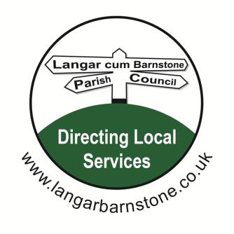
Langar cum Barnstone Parish Council

Parish Clerk:
Mrs Sharon Ellis
22 Brownes Road
Bingham
Nottingham
NG13 8EF

Tel: 07984 075016
Email: langarbarnstoneclerk@gmail.com
Website: www.langarbarnstone.co.uk

PLEASE NOTE:
Following the recent introduction of new legislation:
(The Local Authorities and Police and Crime Panels (Coronavirus) (Flexibility of Local Authority and Police and Crime Panel Meetings) (England and Wales) Regulations 2020)
The Parish Council has taken the decision to hold the Parish Council meeting via video conference. If you would like to attend this Parish Meeting via Zoom or make a comment on any of the agenda items listed below, or have a question on another matter, please contact the Clerk - Sharon Ellis prior to the meeting.

9th July 2020
Dear Councillor,

You are hereby summoned to attend the Parish Council meeting to be held Thursday 9th July 7.30pm by video conference using the following link.

https://us02web.zoom.us/j/88510542744?pwd=ZzRYeUYyK3JINWYwWmQ2SThUaTcwdz09

Meeting ID: 885 1054 2744
Password: 223306

Sharon Ellis Parish Clerk Dated: Friday 3rd July

A G E N D A
1. Declarations of Interests.
2. Apologies for absence.
3. Approval of Parish Council Meeting held on the 11th & 18th June 2020.
4. Matters for report.
5. Public open session.
6. Village Hall including:
a. Welham Architects – To ratify the plans, so that tenders can be applied for and budgets set.
b. Grant re loss of earnings.
7. Police reports.
8. Borough & County Council reports.
9. Planning Applications:
There are no new planning applications
10. Planning Notifications:
There are no new planning notifications
11. Finance for Parish Council: - All Finances to follow due to problems accessing the bank account.
a. Financial Statement & bank reconciliation 30th June 2020: (report attached at Appendices 1 & 2)
b. Accounts paid prior to meeting: (report attached Appendix 3)
c. Accounts for payment at the meeting: (report attached Appendix 4)
12. Finance for Village Hall: All Finances to follow due to problems accessing the bank account.
a. Bank reconciliation 30th June 2020: (report attached Appendix 5)
b. Accounts paid for & for payment: (report attached Appendices 6 & 7)
Matters for consideration
13. Muga/Park
14. Kent Services
15. Correspondence including:
a. Virtual meetings re 4th July
16. Risk Assessments
17. Housing Development- Orchard Close
18. Councillors Reports
19. Date of next meeting: Thursday 10th September 2020
In accordance with Section 1(2) of the Public Bodies Admissions to Meetings Act 1960 it is resolved that, due to the confidential nature of the business to be transacted, the public and press are asked to leave the meeting during consideration of:
19. Private & Confidential Business
a. Employees

Members of the public are welcome to attend all Parish Council meetings. There is a 15 minute Open Session at the start of each meeting, for residents to raise items of interest or ask questions. A full set of meeting papers is available on application to the Clerk, above, or at www.langarbarnstone.co.uk

