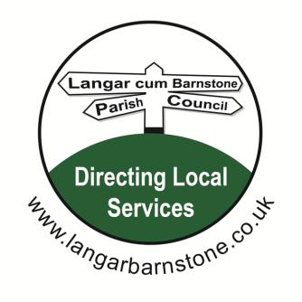
Langar cum Barnstone Parish Council

Parish Clerk:
Mrs Sharon Ellis
22 Brownes Road
Bingham
Nottingham
NG13 8EF

Tel: 07984 075016
Email: langarbarnstoneclerk@gmail.com
Website: www.langarbarnstone.co.uk

PLEASE NOTE:
Following the recent introduction of new legislation:
(The Local Authorities and Police and Crime Panels (Coronavirus) (Flexibility of Local Authority and Police and Crime Panel Meetings) (England and Wales) Regulations 2020)
The Parish Council has taken the decision to hold the Parish Council meeting via video conference. If you would like to attend this Parish Meeting via Zoom or make a comment on any of the agenda items listed below, or have a question on another matter, please contact the Clerk - Sharon Ellis prior to the meeting.

23rd July 2020
Dear Councillor,

You are hereby summoned to attend the Parish Council meeting to be held Thursday 23rd July 7.30pm by video conference using the following link.

Join Zoom Meeting
https://us02web.zoom.us/j/83967127423?pwd=aHpOeEJmTEttdkc2eVB3OFNhakFCZz09

Meeting ID: 839 6712 7423
Password: 643163

Sharon Ellis Parish Clerk Dated: Friday 17th July

A G E N D A
1. Declarations of Interests.
2. Apologies for absence.
3. Approval of Parish Council Minutes held on the 9th July 2020.
4. Public open session.
5. Setting up of an Amenities’ Committee

6. Planning Applications:
20/01615/FUL: Orchard Close
Development: Demolition of existing garages and erection of two no. 2 storey houses with
associated parking. Creation of an area of hard-standing for use for 9 car parking spaces.
Location: Garages South Of 15 Orchard Close Orchard Close Barnstone Nottinghamshire

7. Date of next meeting: Thursday 10th September 2020

