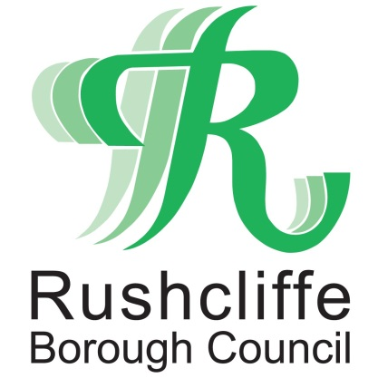 | Press Release

FOR IMMEDIATE RELEASE REF. ELECTRIC
10.03.21

Top up on the go with electric vehicle charging point now available in Keyworth

Electric vehicles (EV) owners can now top up on the go, thanks to a new charging point installed at Bunny Lane Car Park in Keyworth, bringing fast, convenient and reliable facilities to drivers wishing to do their bit to help protect the environment.

The new BP Pulse charging point enables EV and hybrid users to quickly charge their vehicles as they visit the village or call by on their way through, with major routes of the A60 and A606 only a short distance away.

This addition to the Borough’s expanding network of electric charging facilities means that users of the car park can now rely on this sustainable source of power in addition to their home charging connections.

Anyone can utilise the new facility, including D2N2 or Charge Your Car (CYC) cardholders, users of the Charge Your Car App, BP Pulse members and guests. The machine also accepts contactless payments to help support efficient top ups.

Rushcliffe Borough Council’s Deputy Leader Cllr Andy Edyvean said: “We’re thrilled to bring public electric charging points to Keyworth and provide the village and surrounding areas with the technology needed to support more environmentally-friendly journeys across our Borough.

“From experience, I know that electric and hybrid vehicles offer a whole host of benefits for the driver, their community and our environment. This infrastructure will help support further residents in making the switch to greener transport.”

Cabinet Portfolio Holder for Community and the Environment Cllr Abby Brennan said: “The charging point is an essential part of our work to become Carbon Clever and help reduce the environmental impact of our operations and become carbon-neutral by 2030.

“As a Council, we’re committed to installing more electric charging points across the Borough, to help expand on the existing network that already includes facilities at Rushcliffe Arena in West Bridgford and there should be an update on a site at Radcliffe on Trent soon.

“We very much hope this will further encourage use of electric or hybrid vehicles, confident in the knowledge that these easy-to-use, accessible charging points are becoming ever more commonplace.”

The installation follows the Council’s recent electric vehicles survey, which asked residents what factors might encourage them to own, charge or maintain a battery or plug-in hybrid vehicle.

The authority is now pursuing an ambitious programme of electric charging facility installations at locations across the Borough to help further encourage sustainable travel for drivers.

Cllr John Cottee, Borough Councillor for Keyworth and Wolds said: “It’s fantastic to see these developments taking place that will truly enhance the lives of local people and provide nearby residents with further support for sustainable travel.

“I look forward to seeing this new facility used by busy shoppers, visitors and members of our community taking a trip to Keyworth in the months and years ahead.”

- ENDS -

NOTE TO EDITORS
For information please contact the Rushcliffe press office on 0115 9148 555 or media@rushcliffe.gov.uk

For the latest news and events, follow @rushcliffe on Twitter or Rushcliffe on Facebook or go to the council's website.

